TC15 TC16 TC17 TC18 TC19 TC20 and TC21

**Test Scenario:**

* TC15: ESS User able to edit Emergency Contact details
* TC16: ESS User able to add multiple Emergency Contact details
* TC17: ESS User able to delete Emergency Contact details
* TC18: ESS User able to delete multiple Emergency Contact details
* TC19: ESS User able to add attachment under Emergency Contact details
* TC20: Negative Scenario : ESS User should not able to add alphabets in Telephone under Emergency Contact details
* TC21: Negative Scenario : ESS User should not able to add numericals in Name and Relationship under Emergency Contact details

**Test Case Steps:**

* TC15:

1. Launch bowser
2. Login to OrangeHRM web portal
3. Click on My Info
4. Click on More
5. You will see Emergency Contacts option.
6. Click on Emergency contacts Details.
7. Click on Plus icon/symbol under Emergency contacts
8. Add Emergency contact details such as name, relationship and telephone details
9. Click on save button.

* TC16:

1. Launch bowser
2. Login to OrangeHRM web portal
3. Click on My Info
4. Click on More
5. You will see Emergency Contacts option.
6. Click on Emergency contacts Details.
7. Click on Plus icon/symbol under Emergency contacts
8. Add Emergency contact details such as name, relationship and telephone details
9. Click on save button.
10. Add multiple contact details in same way (follow step 7 to step 9 again)

* TC17:

1. Launch bowser
2. Login to OrangeHRM web portal
3. Click on My Info
4. Click on More
5. You will see Emergency Contacts option.
6. Click on Emergency contacts Details.
7. Select checkbox of contact detail you want to delete.
8. Now click on three horizontal dots beside name
9. You will receive list of operations which you can perform such as Select All, Deselect All and Delete Selected.
10. Since we want to delete our emergency contact/entry, click on delete selected.
11. After clicking on Delete Selected, you will receive "Successfully Deleted" Popup message.

* TC18

1. Launch bowser
2. Login to OrangeHRM web portal
3. Click on My Info
4. Click on More
5. You will see Emergency Contacts option.
6. Click on Emergency contacts Details.
7. Select multiple checkboxs of contact details you want to delete.
8. Now click on three horizontal dots beside name
9. You will receive list of operations which you can perform such as Select All, Deselect All and Delete Selected.
10. Since we want to delete our emergency contact/entry, click on delete selected.
11. After clicking on Delete Selected, you will receive "Successfully Deleted" Popup message.

* TC19:

1. Launch bowser
2. Login to OrangeHRM web portal
3. Click on My Info
4. Click on More
5. You will see Emergency Contacts option.
6. Click on Emergency contacts Details
7. Click on Add button
8. Browse for document you want to add
9. Upoad document and click on Save button
10. File should be attached and visible in Attachments under Emergency Contacts

* TC20: Negative Scenario

1. Launch bowser
2. Login to OrangeHRM web portal
3. Click on My Info
4. Click on More
5. You will see Emergency Contacts option.
6. Click on Emergency contacts Details.
7. Click on Plus icon/symbol under Emergency contacts
8. Add Alphabetical values for Emergency contact details such as Telephone
9. It should not allow Numericals in Name and Relationship box and error message "Allows numbers only + - / ( )" should be visible.

* TC21: Negative Scenario 2

1. Launch bowser
2. Login to OrangeHRM web portal
3. Click on My Info
4. Click on More
5. You will see Emergency Contacts option.
6. Click on Emergency contacts Details.
7. Click on Plus icon/symbol under Emergency contacts
8. Add Numerical values for Emergency contact details such as name and relationship
9. It should not allow Numericals in Name and Relationship box and error message "Allows alphabets only" should be visible.

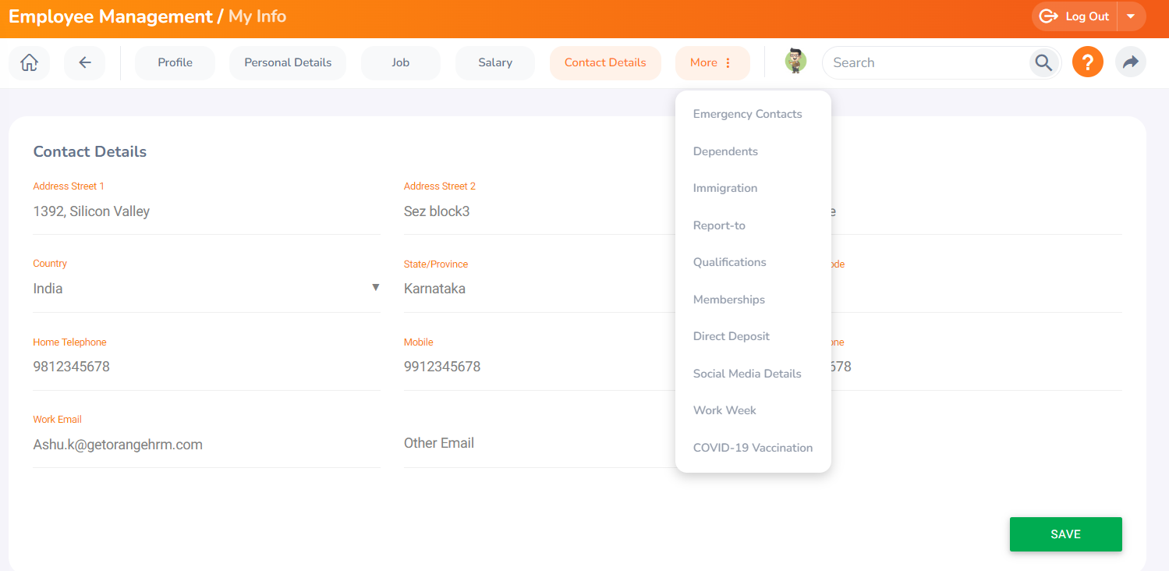

**Click on Emergency Contacts :**

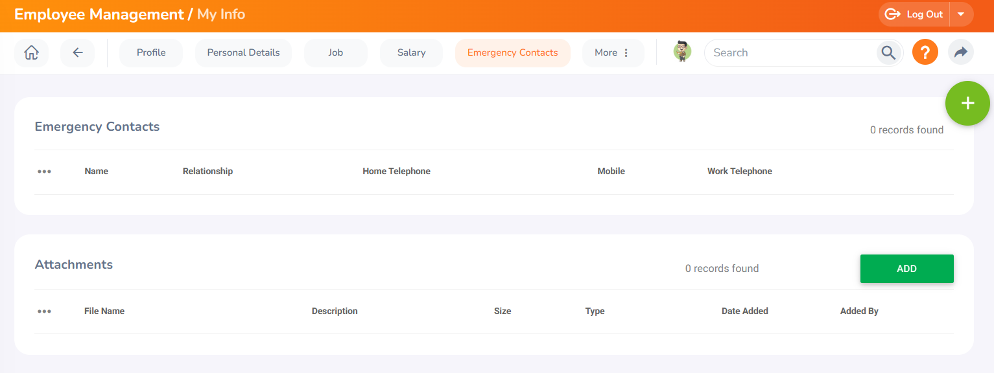

**Now let’s add Emergency contact details. For that we have to click on “Plus” icon/symbol on the corner of Emergency Contacts box (TC15):**

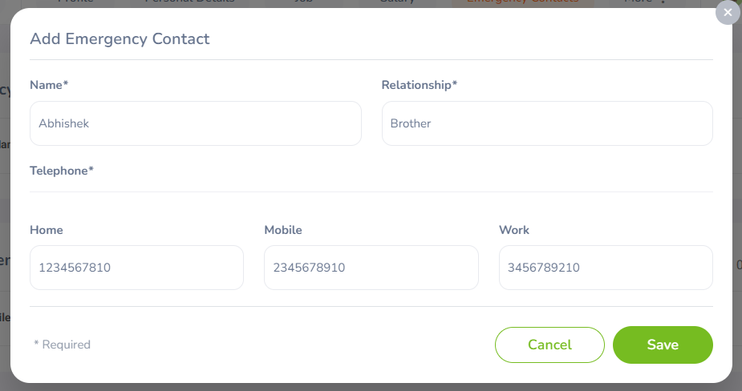

**Now let’s click on save button:**

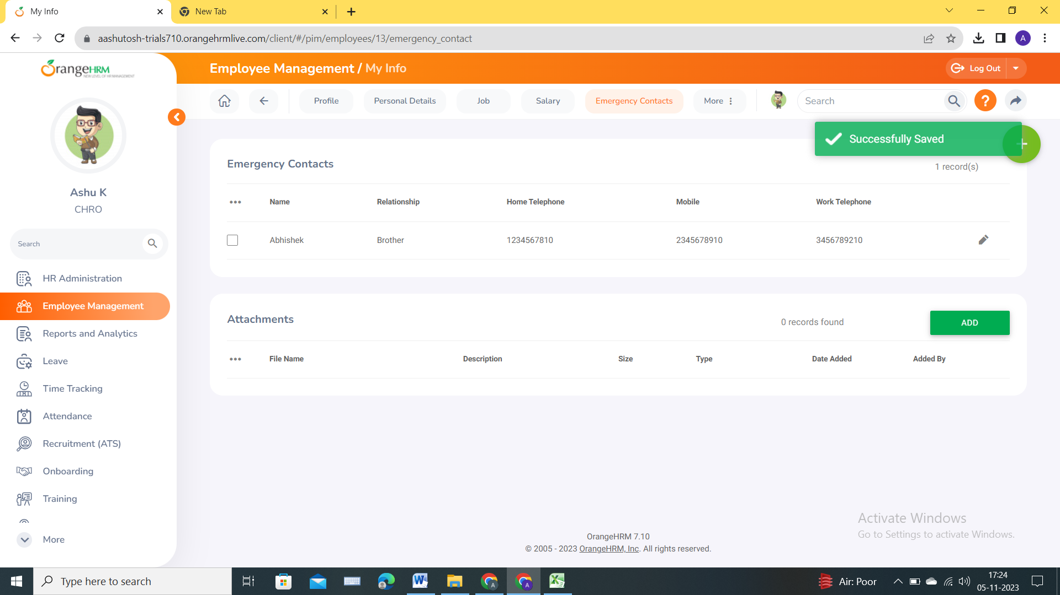

**Now let’s add more/multiple Emergency Contacts:**

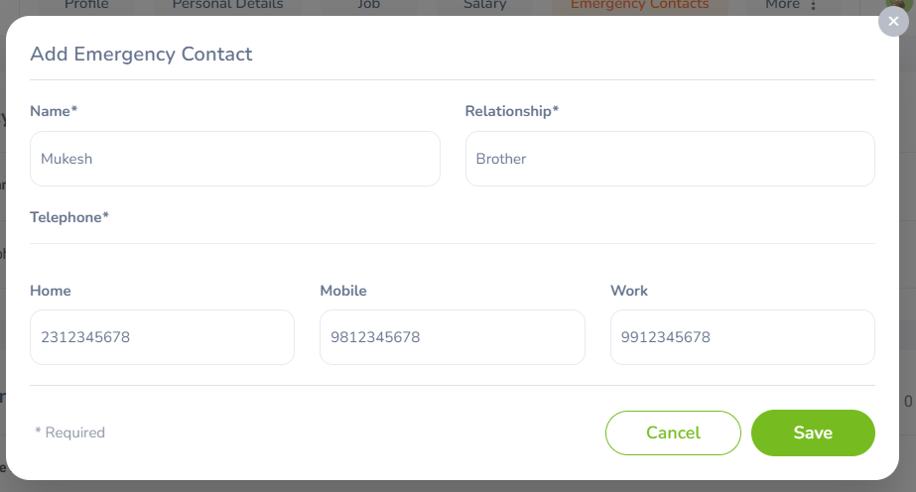

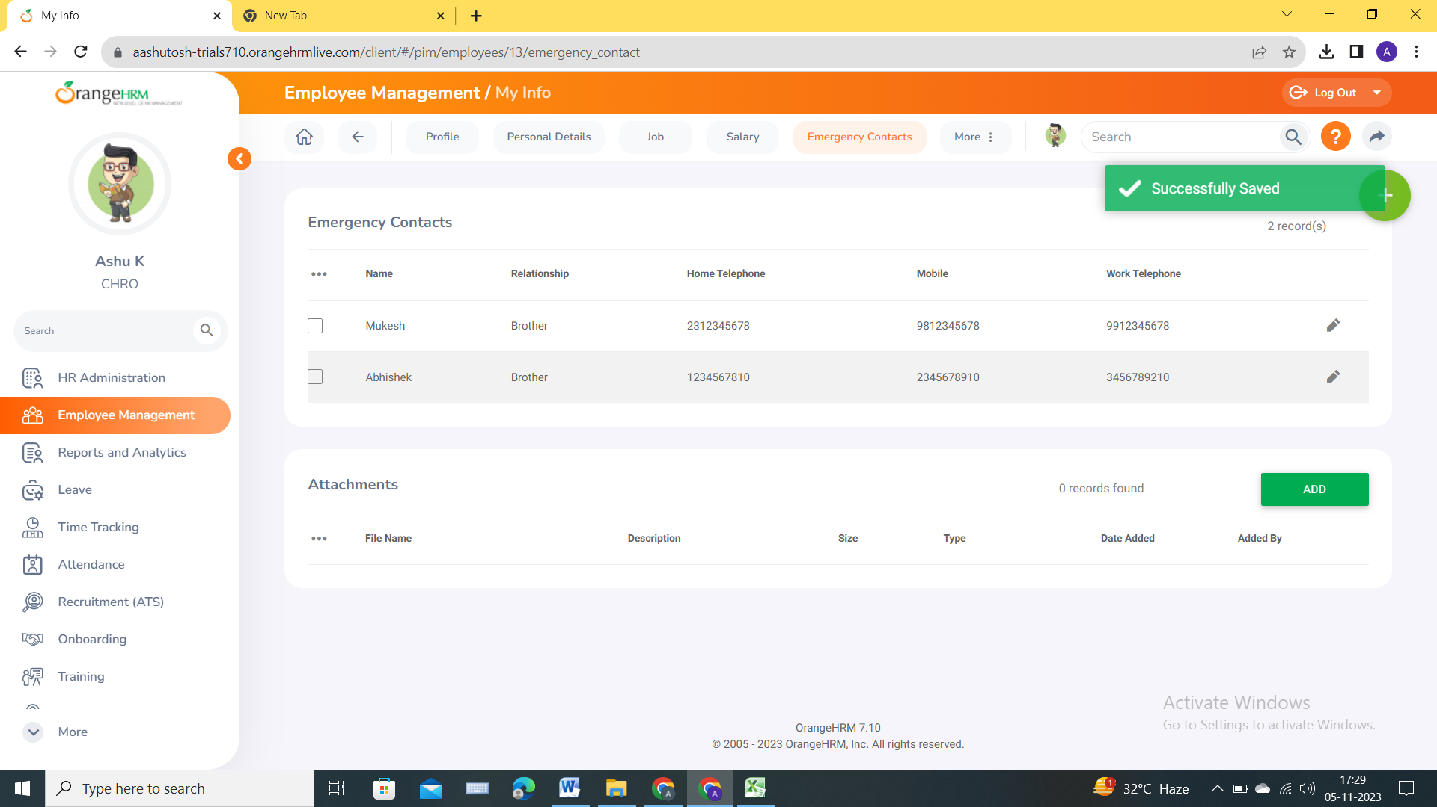

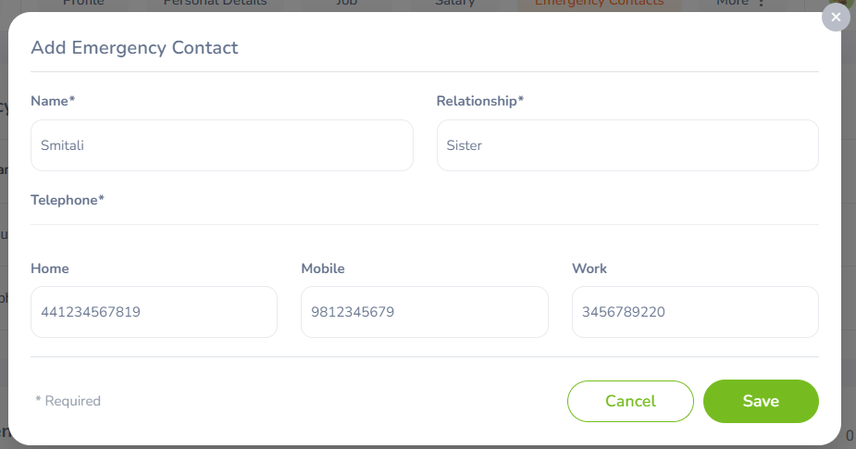

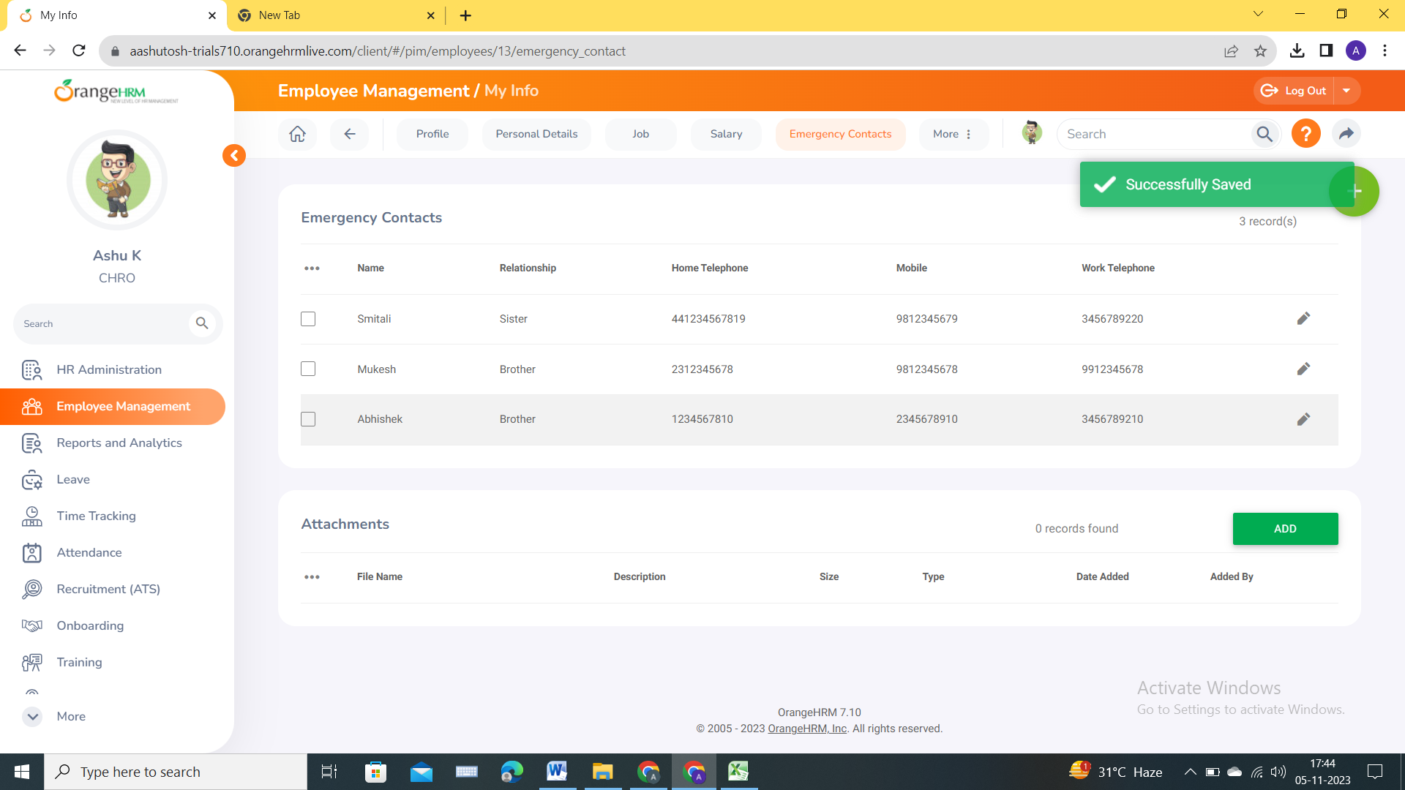

**Note/Result: Here we can add multiple Emergency Contacts**

**Now let’s try to delete Emergency contact details manually (TC17 and TC18). For deleting we need to first select checkbox in front of entries which we want to delete :**

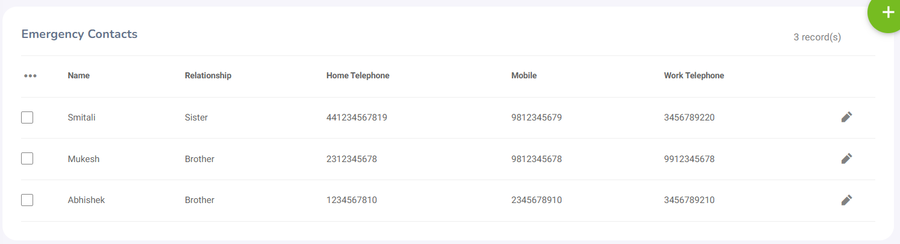

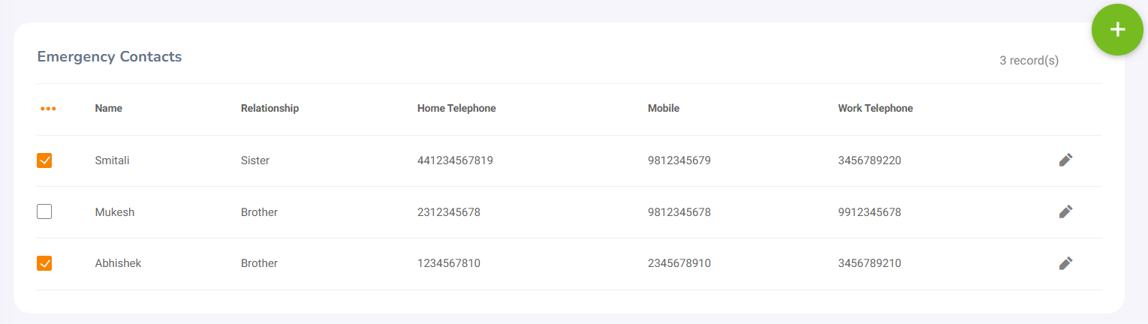

**After selecting checkbox click on 3 dots (as shown in above image) beside name and click on delete selected:**

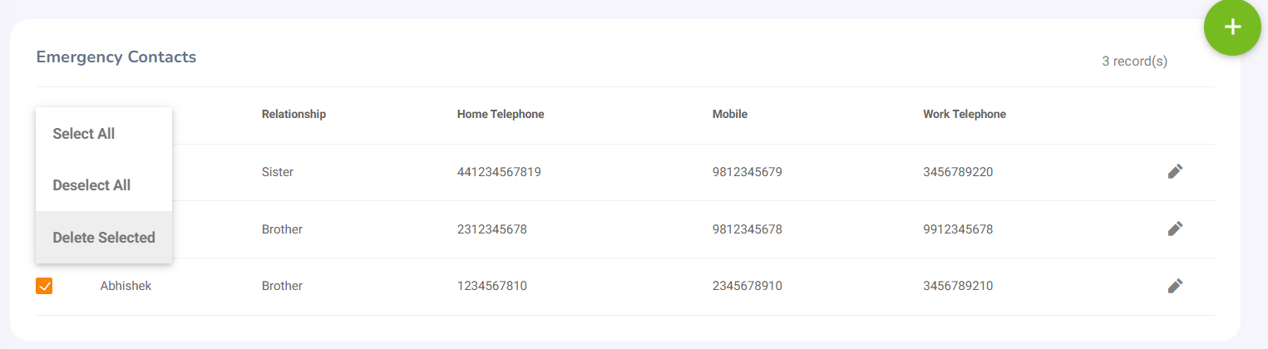

**After clicking on Delete Selected you will receive popup window as below :**

Are you sure?

×

You are about to delete data permanently. Are you sure you want to continue?

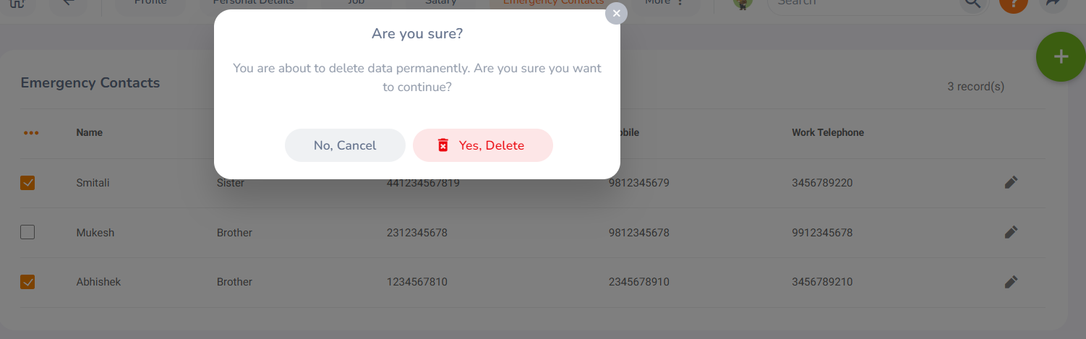

**Click on Yes, Delete:**

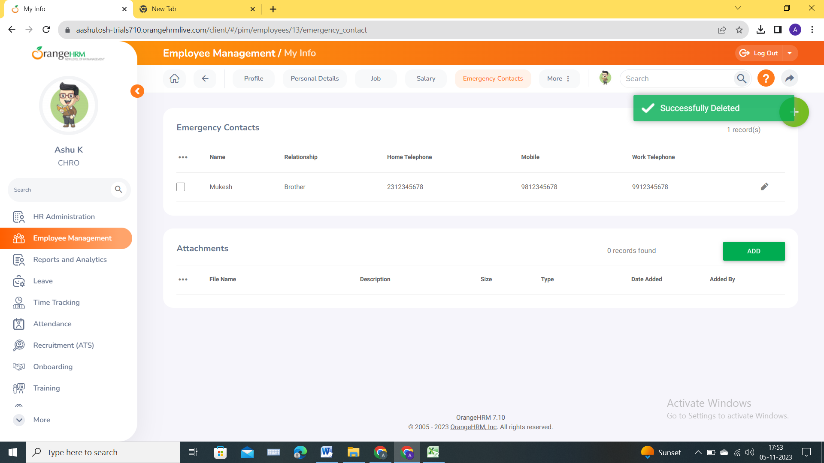

**We can see that selected Emergency contacts are deleted successfully.**

**Now let’s add Attachment under Emergency Contacts (TC19):**

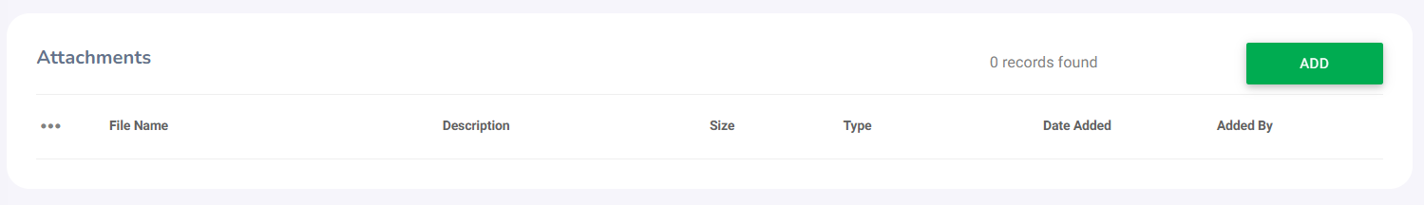

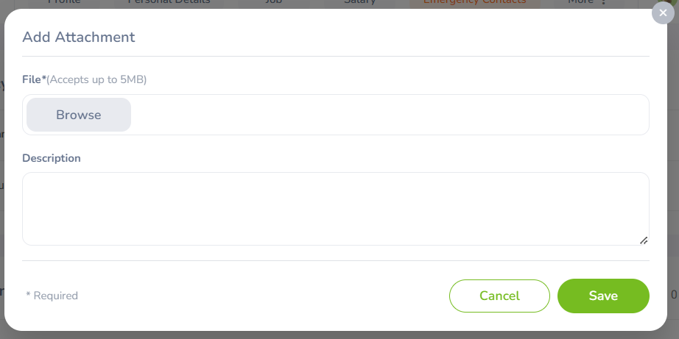

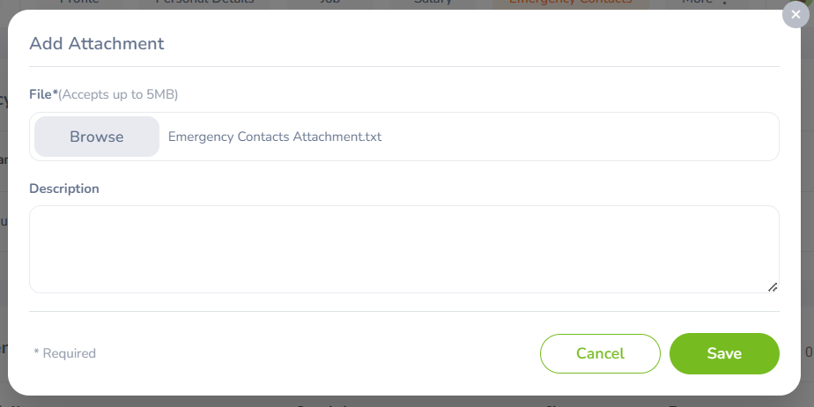

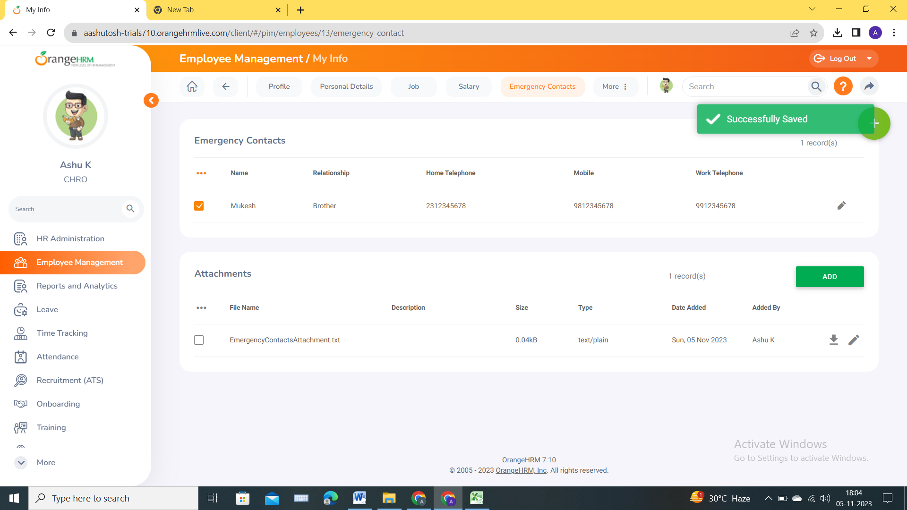

**We can view uploaded attachment in Emergency Contact-Attachment section. Scenario has been passed.**

**TC20 Testing (Negative Scenario):**

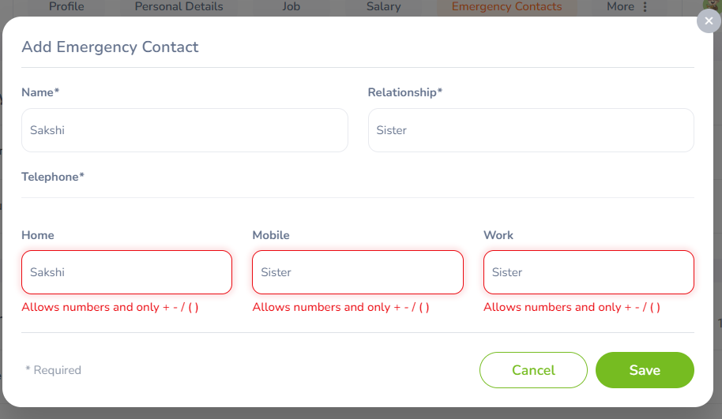

**We can see expected error message for TC20.**

**Now let’s test TC21:**

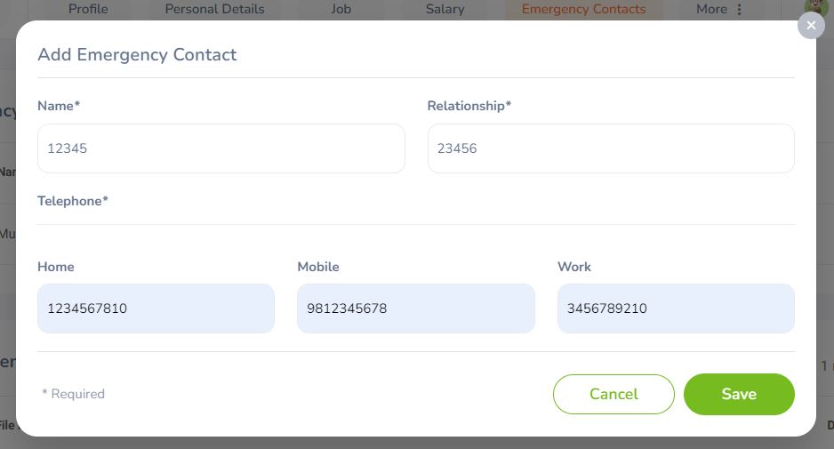

Here in Name and Relationship numerical values should not be allowed. Name and Relationship are always Alphabetical (At least till now 2023). Also after adding numerical value in name and relationship error message should have been visible/showed. Example : **Allows alphabets only.**